Denoising microscope images in python

**→ Gaussian filter in denoising:**

from skimage import io

from scipy import ndimage as nd

from matplotlib import pyplot as plt

img = io.imread("C:\\Users\\abc\\Desktop\\image\\aeroplane\\test_image.jpg")

gaussian_img = nd.gaussian_filter(img, sigma=3)

plt.imsave("C:\\Users\\abc\\Desktop\\image\\aeroplane\\gaussian.jpg",gaussian_img)

**Output :**

**Original Image : Gaussian Image :**

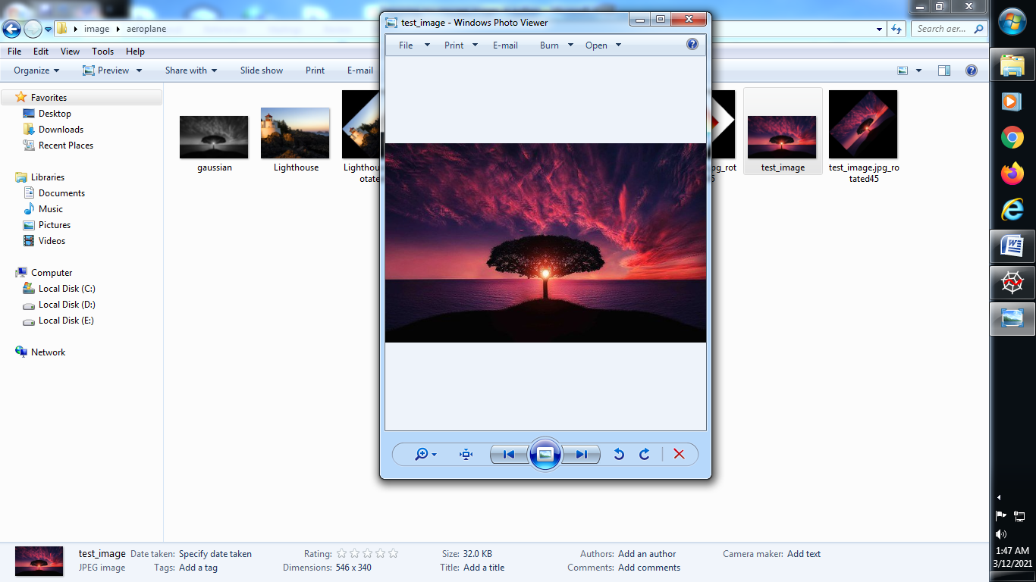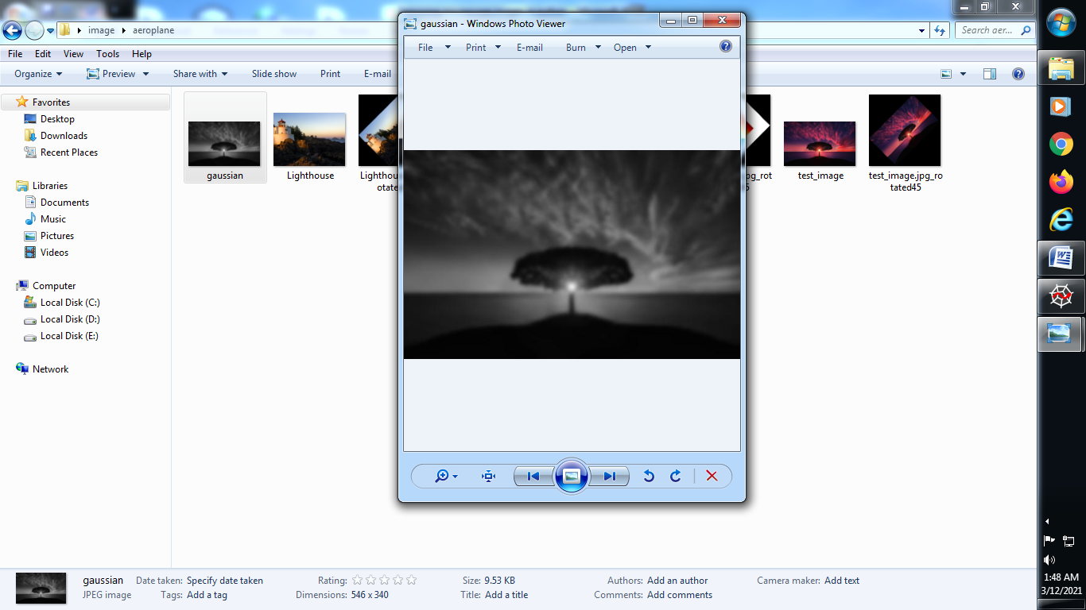

**→ Median filter in denosing :**

from skimage import io

from scipy import ndimage as nd

from matplotlib import pyplot as plt

img = io.imread("C:\\Users\\abc\\Desktop\\image\\aeroplane\\test_image.jpg")

gaussian_img = nd.gaussian_filter(img, sigma=3)

plt.imsave("C:\\Users\\abc\\Desktop\\image\\aeroplane\\gaussian.jpg",gaussian_img)

median_img = nd.median_filter(img,size = 3)

plt.imsave("C:\\Users\\abc\\Desktop\\image\\aeroplane\\median.jpg",median_img)

**Output :**

**Original Image : Gaussian Image :**



**Median Image :**

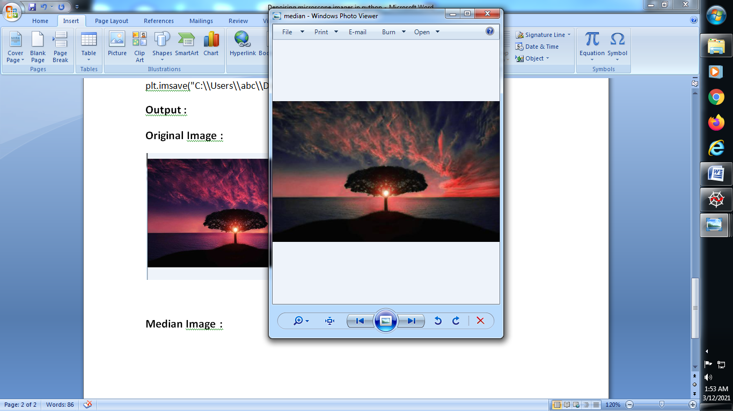

**→ denoise filter image :**

from skimage import io,img_as_float

from scipy import ndimage as nd

from matplotlib import pyplot as plt

import numpy as np

img = img_as_float(io.imread("C:\\Users\\abc\\Desktop\\image\\aeroplane\\test_image.jpg"))

gaussian_img = nd.gaussian_filter(img, sigma=3)

plt.imsave("C:\\Users\\abc\\Desktop\\image\\aeroplane\\gaussian.jpg",gaussian_img)

median_img = nd.median_filter(img,size = 3)

plt.imsave("C:\\Users\\abc\\Desktop\\image\\aeroplane\\median.jpg",median_img)

from skimage.restoration import denoise_nl_means, estimate_sigma

sigma_est = np.mean(estimate_sigma(img, multichannel=True))

denoise = denoise_nl_means(img, h=1.15 * sigma_est, fast_mode=False,

patch_size=5,patch_distance=6,multichannel=True)

plt.imsave("C:\\Users\\abc\\Desktop\\image\\aeroplane\\denoise.jpg",denoise)

**→ Output :**

**Original Image : Gaussian Image :**



**Median Image : Denoising Image :**

